Geometry: Unit 6, Lesson 12

- Solve the equation $4.25x-4=7.35x-10.82$ for $x$.

$$2.2$$

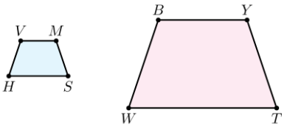
- An image of two similar trapezoids is shown where $VMSH \sim BYTW$. The scale factor from $BYTW$ to $VMSH$ is $\frac{2}{5}$ and $MV=8$. What is the value of $YB$?

$$20$$
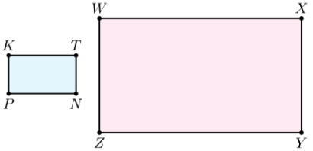
- Rectangles $KTNP$ and $WXYZ$ are shown. $KTNP$ is dilated by a scale factor of $3$ to create $WXYZ$. $KT=4x+2$. What is an expression that can be used to represent the length of $\overline{WX}$.

$$12x+6$$

